**DATA GRID AND DATA LIST CONTROLS**

**PROGRAM**

<asp:DataList ID="DataList1" runat="server">

<ItemTemplate >

<%#Container.DataItem("Stud_Regno")%>

<%#Container.DataItem("Stud_Name")%>

<%#Container.DataItem("Dept_Name")%>

<%#Container.DataItem("Marks")%>

</ItemTemplate>

</asp:DataList>

Imports System.Data.OleDb

Public Class **WebForm1**

Inherits System.Web.UI.Page

Dim con As OleDbConnection

Dim cmd As OleDbCommand

Dim rd As OleDbDataReader

Dim ca As OleDbDataAdapter

Dim ds As New DataSet

Protected Sub Page_Load(ByVal sender As Object, ByVal e As System.EventArgs) Handles Me.Load

con = New OleDbConnection("Provider=Microsoft.Jet.OLEDB.4.0;Data Source='D:\sample.mdb';Persist Security Info=True")

con.Open()

cmd = New OleDbCommand("select distinct(Dept_Name) from student", con)

rd = cmd.ExecuteReader()

If Not Page.IsPostBack Then

While rd.Read()

DropDownList1.Items.Add(rd("Dept_Name"))

End While

End If

con.Close()

End Sub

Private Sub DropDownList1_SelectedIndexChanged(sender As Object, e As EventArgs) Handles DropDownList1.SelectedIndexChanged

Dim s As String

con.Open()

s = "select * from student where Dept_Name='" & DropDownList1.SelectedItem.Text & "'"

cmd = New OleDbCommand(s, con)

ca = New OleDbDataAdapter(cmd)

ca.Fill(ds, "student")

GridView1.DataSource = ds

GridView1.DataBind()

DataList1.DataSource = ds

DataList1.DataBind()

con.Close()

End Sub

End Class

**MS Access**

DataBase Name: sample.mdb

Tabel Name : student

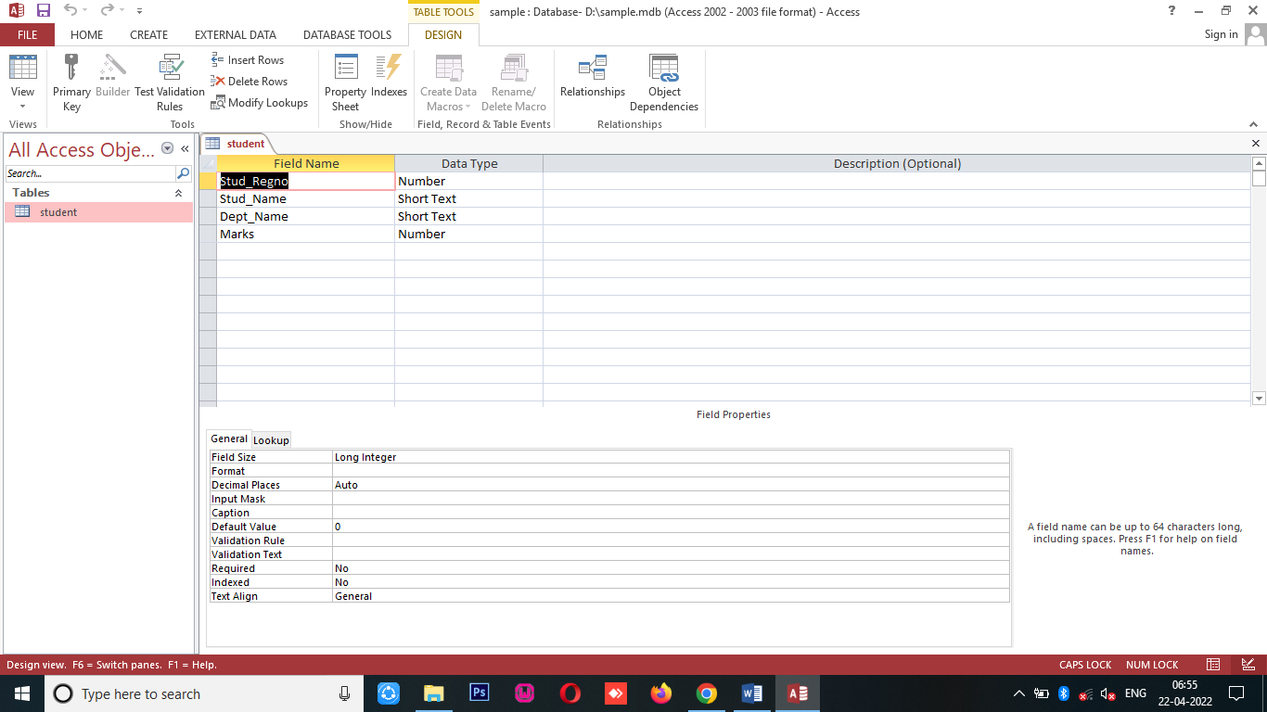

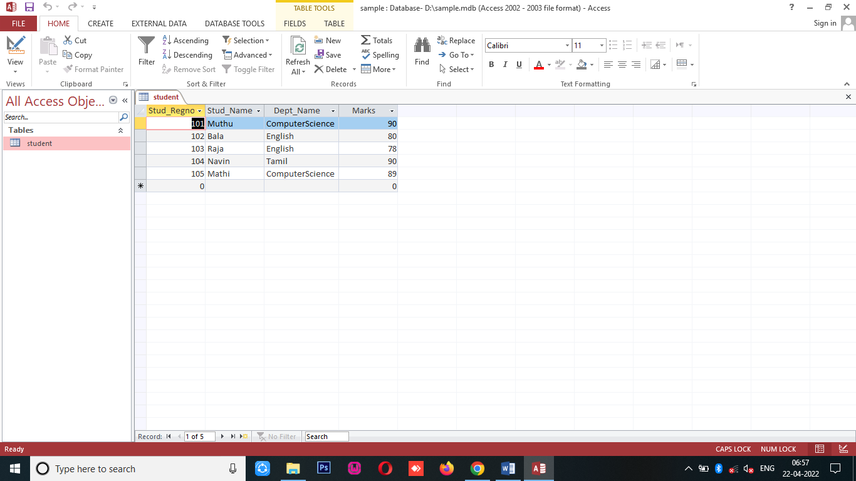

**OUTPUT**

